

**Uttara University**

Assignment-01

**Course Title : INTERNET PROGRAMMING**

**Course Code : CSEC422**

**Department : Computer Science and Engineering**

**Submitted To: Submitted by:**

**Md. Harun-Ar-Rashid Monsur Fuad Khan**

**Lecturer, ID: 2221081106**

**Department of CSE, Batch : 56 (B)**

**Uttara University Semester: Spring-2025**

**Submission Date: 09-02-2025**

**Title: Implementation and Demonstration of CSS Properties in Web Design**

**Working Procedure:**

1. **HTML Structure**:
   * The page contains a <div> with the class title to display the heading.
   * Several <div> elements with the class box are created, each representing a CSS property.
   * Each box contains a <strong> tag for highlighting the CSS property name and a short description of its effect.
2. **CSS Styling**:
   * The body has a gradient background and uses Flexbox to arrange the boxes.
   * The .title class is styled with:
     + A gradient background.
     + A large font size.
     + A shadow effect.
     + Rounded corners for aesthetics.
   * Each .box:
     + Has a fixed width and height.
     + Uses Flexbox for text alignment.
     + Has a unique background color.
     + Includes borders and shadows for a modern look.
   * Specific CSS properties such as border-radius, box-shadow, opacity, text-transform, etc., are applied to demonstrate their effects inside each corresponding box.
3. **Interactivity**:
   * Some properties (e.g., .hover-effect) change appearance on hover.
   * The .transition class adds smooth animation effects.
   * The .cursor-pointer changes the cursor to indicate interactivity.

**Source Code:**

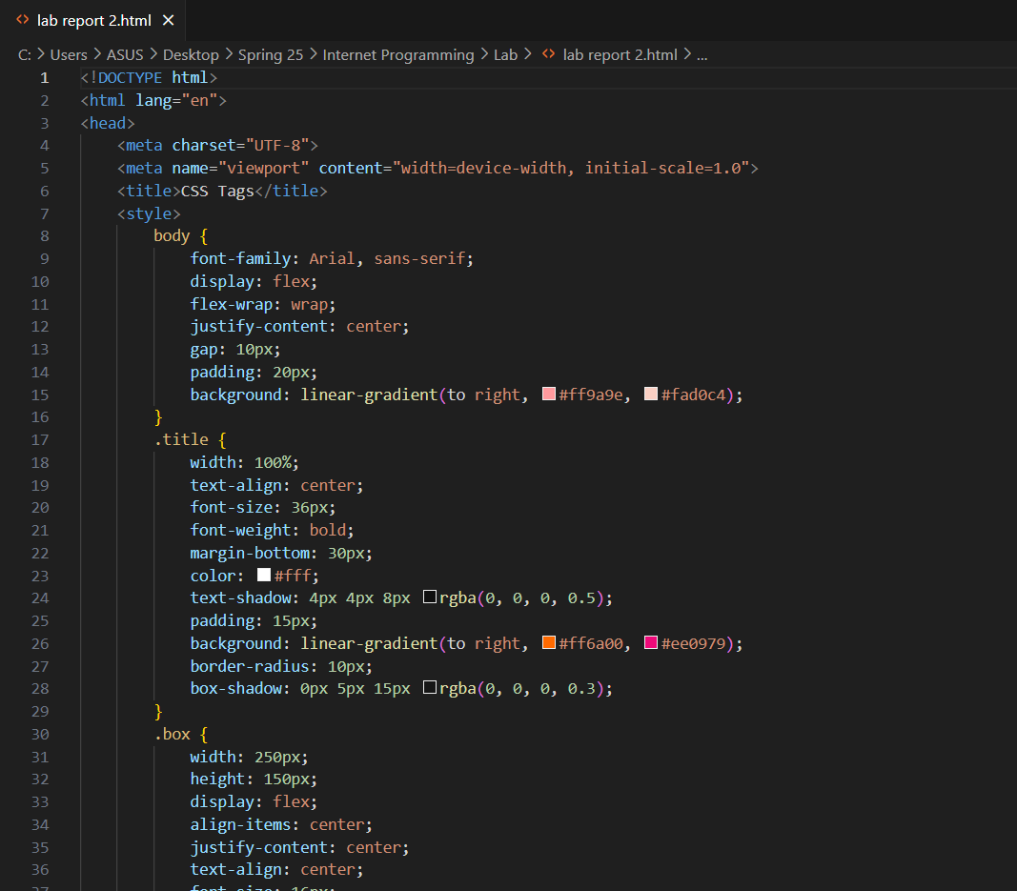

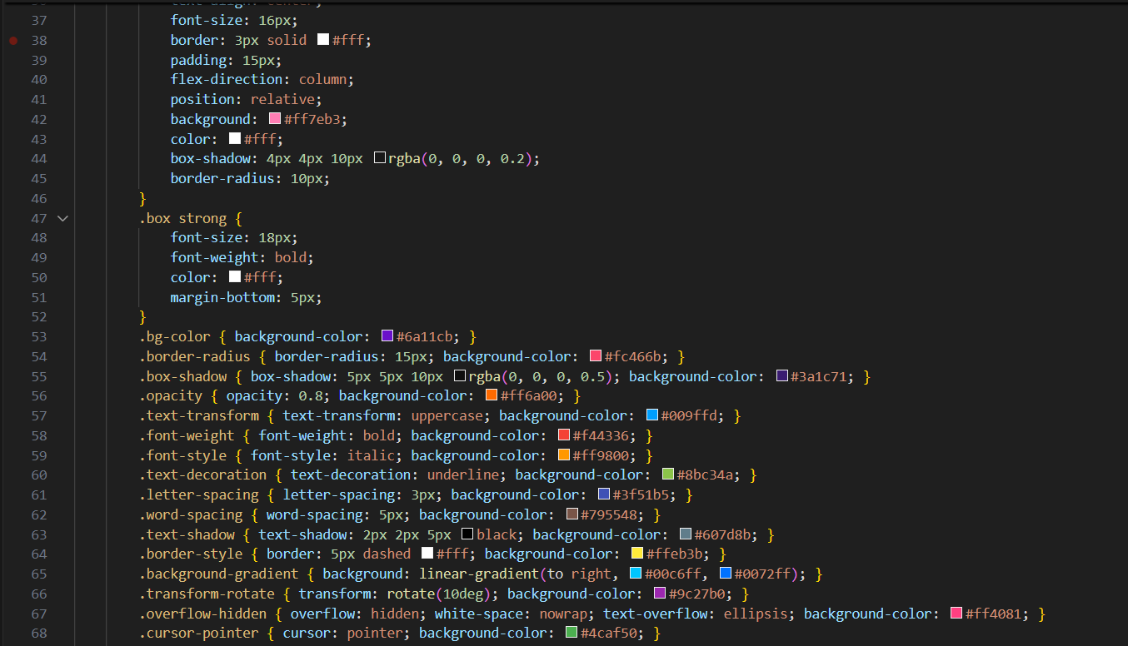

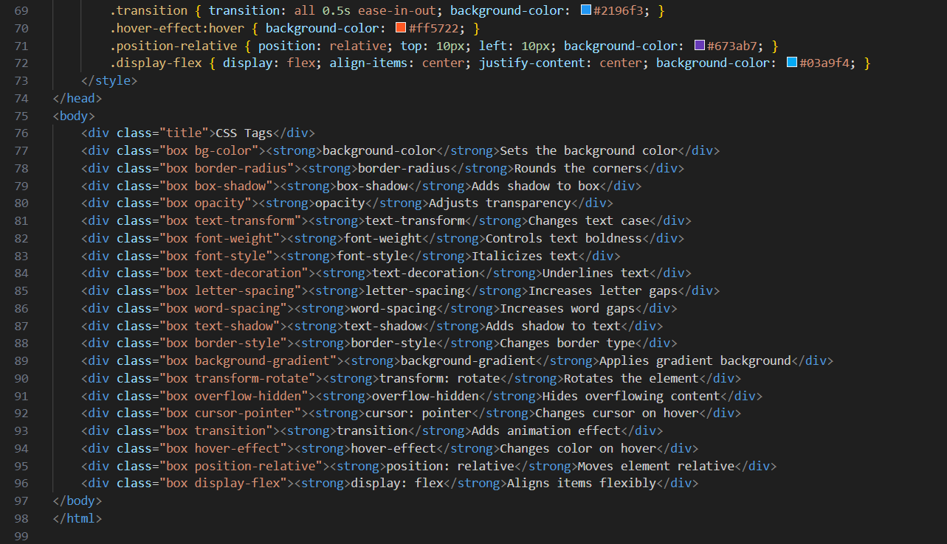

**Output:**

